TECHNICAL PROPOSAL FOR MCG G.C ERP PROJECT

Technical Proposal

Version: 1.0

Document Id: Melka_01_MCG_01

By

MELKA TECH PLC

Feb 2026

Abbreviations/Acronyms

Acronym | EXPLANATION
ERP | Enterprise Resource Planning
BRS | Business Requirement Specification
SRS | System Requirement Specification
SDD | System Design Document
CEO | Chief Executive Officer
BA | Business Analyst
IT | Information Technology
HR | Human Resource
CI/CD | Continues Integration/Delivery
UAT | User Acceptance Test

Executive Summary

The purpose of this technical proposal is to outline the scope, approach, deliverables, timeline, and budget for the successful execution of the MCG G.C ERP project. We are excited about the opportunity to collaborate with MCG G.C and We are confident that our technical expertise will lead to the successful completion of this project. MelkaTech will develop and deploy ERP system which consists of Financial management, Inventory and Store Management system, Human Resource Management, Project management system, Procurement & Supply chain management, and Comprehensive reports and dashboard .

Background

MelkaTech is a leading provider of innovative IT solutions specializing in ERP implementations for diverse industries. Our team brings a wealth of expertise and a proven track record of success to every project we undertake, and Our team comprises seasoned professionals with deep technical expertise in ERP system, along with extensive experience in project management, business analysis, and change management. We understand the complexities involved in ERP implementations and have developed robust methodologies to ensure smooth transitions and maximum return on investment for our clients.

At MelkaTech, we pride ourselves on our ability to collaborate closely with clients, understand their unique business requirements, and deliver tailored solutions that drive tangible business outcomes. With our comprehensive ERP expertise, dedicated team, and client-centric approach, we are confident in our ability to meet and exceed your expectations for this project.

Project Overview / Project Definition

Description

The MCG G.C referenced in this proposal is the development and implementation of an integrated system to streamline various aspects of operations within the organization. This comprehensive solution will encompass the optimization of business processes, efficient financial management practices, the establishment of an advanced inventory management system, streamlined human resource management processes, enhanced supply chain management strategies, and the implementation of robust project management tools. By integrating these key components, the organization aims to enhance efficiency, reduce costs, improve decision-making, and ultimately strengthen its competitive position in the market.

Project Objectives

General Objective
To streamline and optimize the overall business operations by integrating and enhancing the efficiency of Finance, HR, Manufacturing, Procurement, Stock Management, Project management, and Procurement & Supply Chain processes.

Specific Objectives

- Implement a robust financial management system to improve transparency, accuracy, and timeliness of financial reporting.
- Automate financial processes to reduce manual errors and increase operational efficiency.
- Implement an integrated HR management system to centralize employee data and streamline HR processes.
- Develop and implement training programs to enhance employee skills and productivity.
- Streamline procurement processes to reduce cycle times and costs while ensuring quality and compliance.
- Improve procurement visibility and collaboration across departments to enhance strategic sourcing decisions.
- Implement a centralized stock management system to optimize inventory levels and reduce stock outs.
- Enhance demand forecasting capabilities to improve inventory planning and reduce excess inventory.
- Enhance supply chain visibility to improve coordination and responsiveness to customer demands.
- Optimize transportation and logistics operations to reduce costs and improve delivery times.

Scope of Work

Inclusions
- Requirement Analysis and Specification
- Analyze MCG G.C's needs and define technical specifications.
- System Design and Architecture
- Design a scalable, secure system with database structure and integrations.
- Software Development
- Develop ERP system (Financial management, Inventory Management system, Human Resource Management, Procurement & Supply chain management, and project management system) to meet technical specifications.
- Testing and Quality Assurance
- Conduct thorough testing for performance and reliability.
- Deployment and Implementation
- Deploy the system and provide training.
- Post-Implementation Support
- Offer ongoing support, including bug fixes and updates for one year.

Exclusions

- Hardware Procurement: Hardware procurement and associated costs are excluded from this proposal. MCG G.C responsible for hardware.
- Third-Party Licensing: Fees for third-party tools not included.
- Data Migration: Migration from legacy systems not covered.
- Customization Beyond Scope: Additional features may require separate agreement.
- Cloud server for deployment

Constraints, Assumptions and Dependency

Constraints
Possible constraints that are expected in the application development of this project are:-
  - Original requirements may be modified by some kind of business process reforms.
  - The current manual working system may not be capable of offering all the necessary inputs for the proposed system,
  - All the automation part of the project may not be clearly understood by the users at the requirement stage of the system development.

Assumptions
Assumptions that can be expected in the project development process: -
  - There will be good communication between all stakeholders.
  - There will be users that understand their business process.
- There will be willingness to work with us during deployment
- The Institution employees have basic computer skill to use the new software.
- The MCG G.C’s team will work together in collaboration by assigning technical (domain expert) person.
- Well-organized IT infrastructure available to deploy the system.

Dependency
The following lists are the dependencies of the automation system development identified during the development of this document. According to the intension of this document, an in-depth study of the project environment is needed to identify an explicit list of the project dependencies.
  - The deliverables of the project depend on the unchanging workflow and procedures followed by the organization.
  - Infrastructure availability to fully deploy the system.

Project Tolerances

Defining acceptable tolerances for key project parameters is crucial for effective project management. Establishing clear tolerances helps project managers and stakeholders understand the acceptable limits within which the project can deviate without compromising its success. The renewal of contractual agreement is mandatory which requires additional budget and time to undertake the project. Here's a breakdown of acceptable tolerances for each parameter.
- Time: Typically expressed as a percentage deviation from the planned timeline, which is ±15% of the original project duration.
- Cost: Usually expressed as a percentage deviation from the budgeted cost. That is ±10% of the original project budget.
- Scope: Defined by the extent to which the project scope can vary without impacting project success. Minor scope changes within ±5% of the original scope are acceptable without requiring formal change control.
- Risk: Indicates the acceptable level of risk exposure or deviation from the risk management plan. Risks with a likelihood rating of "low" or "medium" are generally acceptable without immediate mitigation actions.
- Stakeholder Satisfaction: Stakeholder satisfaction score should not fall below 75% throughout the project lifecycle.
- Change Management: Specifies the level of change that can be accommodated without significant disruption to project objectives. Changes impacting less than 5% of the project scope can be managed through standard change control procedures.

Project Stakeholder

This project is expected to have more stakeholders. Shows who will have a direct role on the executions of the project. The following tables list the current stakeholders with active roles.
S.No | Stakeholder | Role | Main Responsibility
 | MCG G.C | Project Client | Validate and Accept
 | MelkaTech | Project Contractor | Design, develop, and deliver the Project
Table 1:Project stakeholders

Technical Approach

Our approach ensures a robust solution for MCG G.C.

- Requirement Refinement: Clarify project needs through detailed discussions.
- Agile Development: Embrace adaptability, transparency, and collaboration.
- Modular Architecture: Enhance scalability and facilitate future updates.
- Security and Compliance: Prioritize data protection and regulatory adherence.
- CI/CD Automation: Streamline testing, integration, and deployment.
- Scalability and Performance: Design for growth and optimize user experience.
- Quality Assurance: Rigorous testing for a high-quality final product.
Our approach combines expertise and proven methodologies to align seamlessly with MCG G.C's objectives.

Deliverables/Project Outputs

As a result of the development process of the automation project, along with various project outputs, significant deliverables also emerge. These encompass:
S. N | Product/ Document | Description
1. | Inception report | Serves as a project initiation document that outlines the initial understanding, objectives, scope, approach, and key considerations for a project.
 | Business Requirement Specification (BRS) | This document explores the existing system (Which analyses the problems and strengths of the existing system), identifies the requirements of the automated system because of the analysis and the system model of the proposed system is described.
2. | System Requirement Specification (SRS) | This document gives detail explanation of system design documentation. The document covers clear design functionalities and other documentations, including system functionality, design constraints, detail architectural view, user interface, system performance and also the document dots out: code development, system integration and testing.
3. | System Design Document (SDD) | This document gives detail explanation of system design documentation. The document covers clear design functionalities of Business, Application, Data and Technology Architecture documentations.
4. | Progressive Releases of working modules | Since we follow a Scrum based iterative development process, working modules will be delivered on a progressive manner until all modules are delivered.
5. | Deployed Application and Its Source Code | All software applications/sub-systems well tested and ready to work with completed on site deployment and configuration for all operational processes mentioned in the project scope. Finally, Melka will provide the source code of the system to the MCG G.C.
6. | Training | The approach we follow for training is training of training(ToT). This means that we will give to 5 trainees first for MCG G.C to fully utilize the functionalities of the system effectively, and they will give to the rest.
7. | User/help Manuals | There will be two types of system manuals to be delivered. The user manuals for each software application/subsystem as well as Administration manuals used for configuring, troubleshooting and basic  maintenance operations on the entire system.
 | System Administration and configuration document. | The document provides detailed information about the configuration of a system, software application, or hardware component. It serves as a reference for system administrators, support staff, or anyone involved in  managing or troubleshooting the system.
 | UAT | User Acceptance Test document is prepared for users to test the released final product (ERP) asper the specified parameters for the entire system.
Table 2:project outputs

Project Outcomes/Functional Requirements

Module Name | Functionality and Feature
Human Resource Management module | - Employee Records  - Leave Management  - Payroll Processing  - Attendance Management  - Performance Evaluation  - Statutory compliance reporting
Finance and Accounting Module | - General Ledger  - Accounts Payable & Receivable  - Budget Control  - Fixed Asset Management  - Cash & Bank Management  - Financial Reporting (Balance Sheet, Income Statement, Cash Flow)
Inventory and Stock Management | - Stock Tracking  - Warehouse Management  - Material Requisition  - Stock Transfer  - Minimum/Maximum Level Alerts  - Inventory Valuation
Procurement and Supply Chain | - Supplier Registration & Management  - Purchase Requisition  - Purchase Orders  - Goods Receiving  - Vendor Payment Tracking
Equipment Management System | - Equipment Registry  - Equipment Master Data  - Categorization & Classification  - Specifications & Technical Data  - Documentation Management  - Ownership & Financial Details
Maintenance Management | - Preventive Maintenance  - Corrective Maintenance  - Breakdown Management  - Inspection & Quality Control  - Warranty Management
Operations Management | - Daily Usage Tracking  - Fuel Management  - Operator Assignment  - Project Allocation  - Performance Monitoring

Non-Functional Requirement
Non-functional features are aspects of a MCG G.C ERP system that define its characteristics and qualities, rather than specific functionalities. These features contribute to the overall performance, usability, and efficiency of the system. Here are some important non- functional features that are often expected in MCG G.C ERP system:
Non-Functional Requirement | Description
Scalability | - The ability to scale the MCG G.C ERP system to accommodate growing business needs, whether it's an increase in users, data volume, or transaction volume.
Performance | - Responsive and efficient performance, even under heavy loads or peak times.  - Quick response times for user queries and transactions.
Reliability and Availability | - High system reliability with minimal downtime.  - Ensured availability to support critical business operations 24/7.
Security | - Robust data security measures to protect sensitive information.  - Access controls and user authentication to ensure data integrity.
Usability and User Experience | - Intuitive user interfaces that are easy to navigate.  - User-friendly design to facilitate user adoption and reduce training time.
Data Management and Integrity | - Data consistency and accuracy across all modules.  - Data backup and recovery mechanisms to prevent data loss.
Flexibility and Customization | - Ability to customize workflows, reports, and interfaces based on specific business needs.  - Support for changes in business processes without disrupting operations.
Mobile Accessibility | - Support for mobile devices to enable remote access and on-the-go functionality.
Training and Support | - Adequate training resources and support to assist users in utilizing the ERP system effectively
Documentation | - Comprehensive documentation for administrators and  users

Communication and Report Mechanism

The project management and other team members of the project will collaborate for the successful delivery. Apart from informal interactions, formal meetings will be held periodically and various written reports and deliverables are exchanged between the MCG G.C and the MelkaTech in every milestone of the project.

S. No | Reporting and Communication Mechanism | Frequency | Output | Distribution Tool
1 | Project Kick-off Meeting | Once | Meeting Minutes | E-mail
2 | Technical Committee Meetings | Weekly | Meeting Minutes | E-mail; Signed copies to members
3 | Interim Project Progress Report by MelkaTech | Monthly | Report | E-mail
4 | Formal Project Progress Report by MelkaTech | Monthly | Report | Formal Document

Project Plan / Timelines

An overview of the project timeline, including key deliverables and deadlines.
No. | Work package description | Duration | Deliverables
1. | Requirement gathering and discussion  - Stakeholder interviews  - Business process mapping  - Gap analysis  - Finalization of functional specification document | 2–6 Weeks | BRS and SRS
2. | System Design  - Database design  - System architecture design  - UI/UX design mockups  - Client approval of system design | 3–5 Weeks | D Design
3. | Development  - Module-by-module development  - Internal testing  - Integration testing | 10–18 Weeks | Working System
4. | Testing & Quality Assurance  - User Acceptance Testing (UAT)  - Bug fixing  - Performance testing | 4 Weeks | Tested System
5 | Deployment & Training  - Server setup  - Data migration  - User training sessions  - System go-live  - Phase 6: Post-Implementation Support (3–6 Months) | 2–3 Weeks | TLiv Live System
Total Days |  | Maximum duration: 36 Weeks  Minimum duration: 21 Weeks

- Cost Allocation by Work Package
No. | Work Package | Duration | % Allocation (Revised) | Cost (ETB)
1 | Requirement Gathering & Discussion | 2–6 Weeks | 12% | 1,476,000
2 | System Design | 3–5 Weeks | 15% | 1,845,000
3 | Development | 10–18 Weeks | 55% | 6,765,000
4 | Testing & Quality Assurance | 4 Weeks | 12% | 1,476,000
5 | Deployment & Training | 2–3 Weeks | 6% | 738,000
Total |  | 21–36 Weeks | 100% | 12,300,000

4. DUTIES AND RESPONSIBILITIES
  - Melka Tech Responsibilities
- The Developer shall:
- Develop the ERP system according to agreed specifications.
- Assign qualified project manager, developers, and support team.
- Deliver the project within agreed timeline.
- Provide documentation including:
- User Manual
- System Administration Manual
- Technical Documentation
- Conduct user training sessions.
- Ensure system security and role-based access control.
- Maintain confidentiality of client data.
- Provide warranty support for 6 months after deployment.
- Fix software defects identified during warranty period without additional charge.
- Provide regular project progress reports.
4.2 Client Responsibilities (MCG G.C.)
- The Client shall:
- Provide detailed business requirements and documentation.
- Assign a project focal person for coordination.
- Provide timely feedback and approvals.
- Ensure availability of staff during requirement gathering and testing.
- Provide necessary infrastructure (servers, hosting, internet).
- Ensure timely payment according to agreed schedule.
- Provide accurate data for migration.
- Ensure internal policy alignment with ERP workflows.
- Not modify the system without Developer authorization.

5. Project Timeline
- Estimated total duration: 6 months from signing date.
- Detailed schedule shall be attached as Annex A.
- Any delays caused by Client’s failure to provide required inputs may result in timeline adjustment.

6. Financial proposal
- Total Project Cost: ETB 12,300,000.00
- Payment Schedule:
- 30% upon signing Agreement
- 30% after completion of development phase
- 20% after deployment
- 20% after final acceptance
- All payments shall be made within 7 working days of invoice issuance.
- Applicable VAT and taxes shall be added as per Ethiopian tax law.
7. Confidentiality
Both Parties agree:
- Not to disclose confidential information.
- To protect system data from unauthorized access.
- That confidentiality obligations survive termination.
8. Intellectual Property
- Upon full payment, the Client shall have ownership of the customized ERP system.
- Developer retains rights to generic frameworks, tools, and reusable components.
- Third-party components remain under respective licenses.

9. Termination
- This Agreement may be terminated:
- By mutual consent.
- If either Party breaches the Agreement and fails to cure within 30 days.
- Client shall pay for work completed up to termination date.

10. Limitation of Liability
- Developer’s total liability shall not exceed the total contract value.
- Neither Party shall be liable for indirect or consequential damages.

11. Government Law
This Agreement shall be governed by the laws of the Federal Democratic Republic of Ethiopia.
Disputes shall be settled amicably. If unresolved, disputes shall be submitted to competent courts in Addis Ababa, Ethiopia.

Warranty and support
MelkaTech provides :
- The Developer warrants that:
- The system will function substantially as specified.
- Major defects will be corrected within a reasonable time.
- Warranty Period: 6months after final acceptance.
- Extended maintenance can be provided under separate agreement.

13 . Change Management
We recognize that during the lifetime of the project changes to the project scope, schedule, deliverables and resources (staff, policy, process, technology, materials, etc.) might occur. In such circumstances, it is paramount to apply the change management procedure.
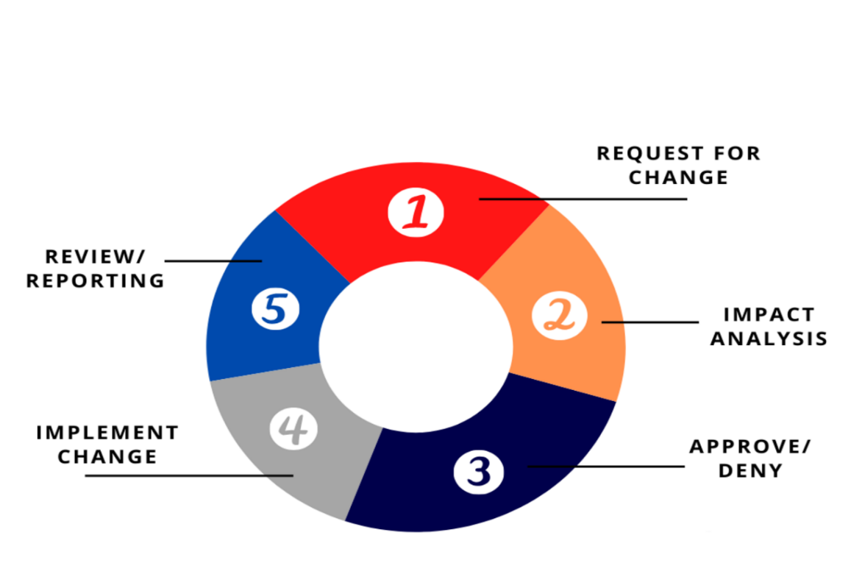
Figure 1:Project Change Management

A change request made by the clients or project stakeholders will be reviewed and approved by the Technical Committee. The Technical Committee is composed of individuals from MCG G.C and MelkaTech, and it discusses on meeting on agenda basis and reaches on agreement whether to consider the change or look for alternative solutions after assessing implications to the project triple constraints: scope, time and resource/cost.

Managing project risks
Well-proven risk management of the MelkaTech company allows to control the project risks. The project shall be monitored: from the viewpoint of risk priority changes, new risks occurrence as well as events leading to possible risk and indicating the need of taking adequate steps. Risk management shall be regular part of the implementation process. It will be repeated in any event of project change, issue or risks related to important decisions on project progress. Methods of risk management shall include:
- Identification of risks
- Evaluation of risks
- Defining measures of risk management
- Introduction of resulting tasks in the project schedule
- Regular monitoring of each risk status

14. SIGNATURES
IN WITNESS WHEREOF, the Parties have signed this Agreement on the date first written above.

For MCG G.C For Melka Tech
Name: ____ Name: _______
Title: ____ Title: ____
Signature: ___ Signature: ___
Date: ____ Date: ____

​​[Sender.Fir

stName] ​[Sender.LastName]​

